

NAME: AMMAR

REG NO # FA19-BCE-001

Section: CE-4

Project Title: IRON MAN 3D MODEL

Submission Date: 29 June, 2021

Submitted To: Mr. Shahab Yousafzia

**Objective:**

To Draw 3D Model of Iron Man Mask Front Part Having Yellow Color

**Unites:**

* **Type:** Decimal
* **Precision:** 0.0
* **Insertion Scale:** Millimeters

**2D Image:**

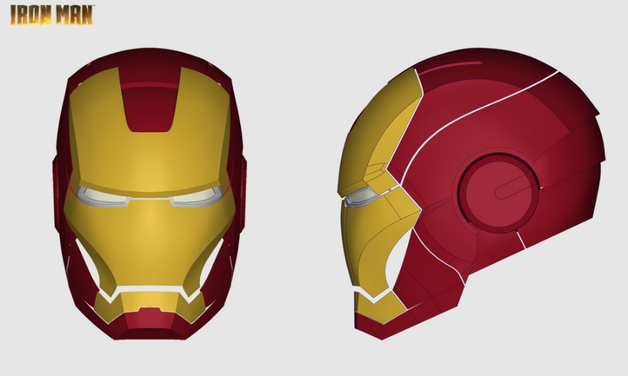

**Methodology:**

* Using front faced image trace all line on fore head using Arc, Line, P-Line, Circle and then trace lines on fore head from side faced image and then align all line so that a cure type structure is obtained and then use Network Surface command and save this part.
* Now trace center part on fore head from both side images and then align then accordingly to obtain that part in curved 3D form and make a surface of it using Network Surface Command.
* Align both part together and mirror the part 1 and we’ll get complete fore head as:

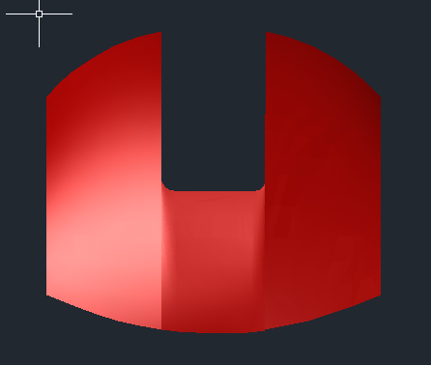

* For area of Nose, Cheeks and Ears trace the area with Lines and Arc and copy them to side.
* Trace lines from side image and before aligning them to left side rotate them 90 degree as they are sides have 90 degree angle as seen from front. Now align them and make them surface as done before.
* For right side mirror the left side and you’ll get shape and to make it perfect for face trace eyes part from 2D image and extrude them on horizontal surface.
* Now place this on face mask and subtract it from main face mask and align it :

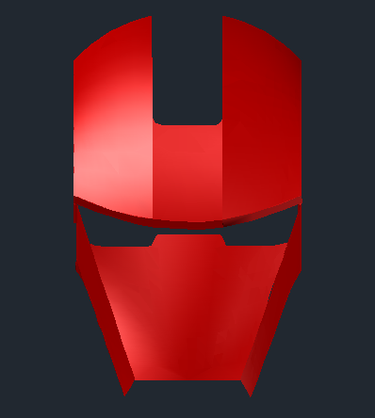

* Same for jaw line part trace Lines on front faced image and copy them and then trace from side image and align them accordingly remember we always draw one left part on 90 degree and mirror the right.
* Use Network surface command and then mirror for right Jaw and align with pervious drawing and you 3d model is complete as:

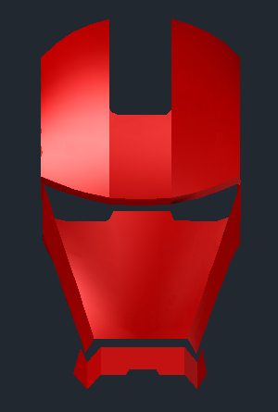

* At end just Union them all and delete garbage in drawing to make project neat and clean.

**Challenges:**

* **Dimensions:** Initially I got two options draw using dimensions or use tracing method. I preferred tracing method because requirements were only 3D model not 2d and it would be lengthy and time consuming to 1st draw 2D and then 3D. This technique was more efficient.
* **Network Surface or Extrude:** We use Extrude when we have object of some good diameter or thickness while Network Surface is used just make solid 3D surface such as thin metal foil. I used Network Surface because I reality this part is made up of thin metal and extrude won’t work here.
* **Curves:** Tracing curves with Network Surface was a challenge because image I used was perfect so managing left right was hard but at last it’s done and completed.

**Command Used:**

* **Line:** Start the Line command by clicking the Line button on the Draw panel on the Ribbon, or by entering L and then pressing Enter. Draw line segments by picking several random points. Terminate the command by pressing Enter, Esc, or the spacebar. Press Enter or the spacebar to repeat the Line command.
* **P-Line:** The P Line command draws a single, connected, multi segment object. A polyline is what a line appears to be; each segment is connected to form a single object. If you select any segment for editing, the changes affect the entire polyline.
* **Arc:** Menu: Draw > Arc. To create an arc, you can specify combinations of center, endpoint, start point, radius, angle, chord length, and direction values. Arcs are drawn in a counterclockwise direction by default. Hold down the Ctrl key as you drag to draw in a clockwise direction
* **Trim:** The Trim command in AutoCAD is used to remove the objects, which meet the edges of other objects. It is used to remove extra lines or extra parts of an object. We can also perform trim using different selection methods. We are required to select the portion of the object to trim.
* **Network Surface:** A network surface can be created between a network of curves or between the edges of other 3D surfaces or solids. ... Select a network of open curves, open surface edges, or region edges (not the surfaces or regions) for the U or V direction.
* **Extrude:** Creates a 3D solid from an object that encloses an area, or a 3D surface from an object with open ends. Objects can be extruded orthogonally from the plane of the source object, in a specified direction, or along a selected path. You can also specify a taper angle.
* **Union:** Combines two or more **3D** solids, surfaces, or 2D regions into a single, composite **3D** solid, surface, or region. Select two or more objects of the same type to combine.
* **Subtract:** Select the objects that you want to keep, press Enter, then select the objects that you want to subtract. Objects in the second selection set are subtracted from objects in the first selection set. A single new 3D solid or surface is created.
* **Copy & Move:** The COPY command works similarly to the Move command with the only difference that it leaves a copy of the original object in its position. It works as it would in other windows application, and feel free to use the Ctrl+C and Ctrl+V to copy and paste objects in AutoCAD.

**Final Images:**

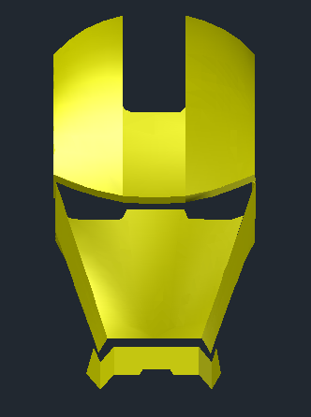 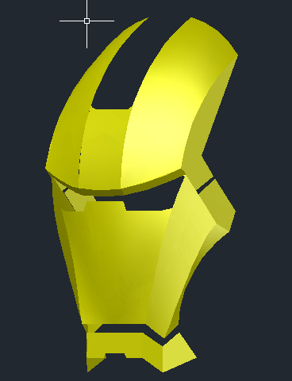 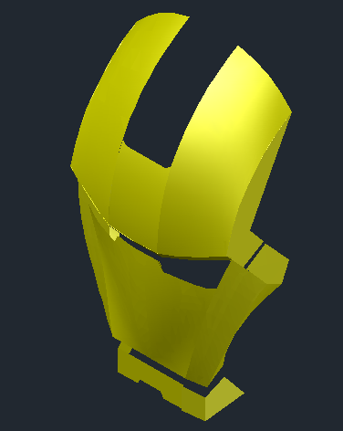

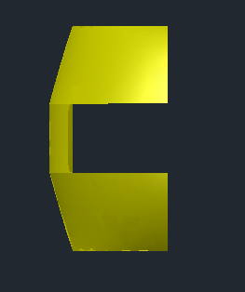 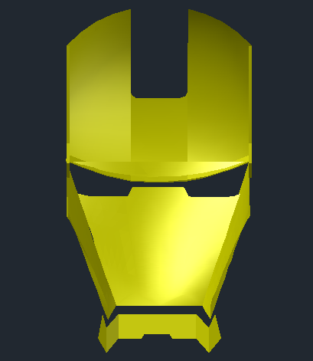 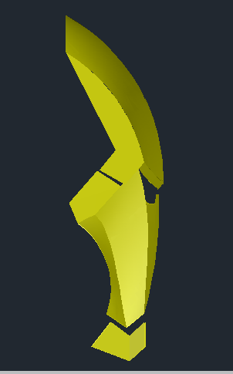

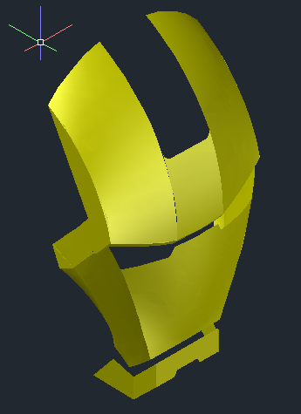 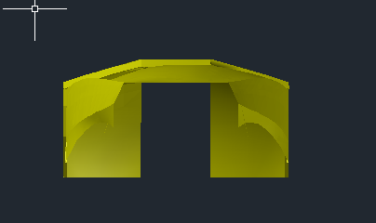

**Conclusions:**

* Draw to Scale. One of the main benefits of AutoCAD is that it allows you to draw to scale.
* Easy Layout and Viewing
* Draw Accurately.
* Make Changes Easily and Reduce Risk of Error.
* Identify Design Problems. ...
* Calculate Material Quantities for Production.
* Store and Transfer Data Safely.
* Save Time and Money
* We get used to all commands we used there were a lot of challenges but with effort we overcome them.

**---------------------------------------------------**